Invesco India Large & Mid Cap Fund vs Motilal Oswal Large and Midcap Fund
Hey! Kabhi socha hai ki do log same exam pass karke, same city mein job start karke bhi, kuch saalon baad bilkul alag jagah pahunch jaate hain? Kyunki raasta same tha, lekin approach alag thi.
Kuch aisa hi hai in dono Large & Mid Cap funds ke saath. Dono SEBI ke same mandate follow karte hain, dono same benchmark ke against measure hote hain, lekin jab hum inke portfolio ke andar jhaankte hain, toh dono ki philosophy bilkul different nikalti hai. Aaj hum dekhenge Invesco India Large & Mid Cap Fund Direct Growth aur Motilal Oswal Large and Midcap Fund Direct Growth, jo pichle 3 aur 5 saal ke returns ke according top 2 positions mein hai.
Video ko aage badhane se pehle like kar dijiye, share kar dijiye aur channel ko subscribe kar lijiye, taaki aise hi insightful comparisons aapko miss na ho!
Chaliye shuru karte hai!
Pehle kuch basic important notes:
Invesco India Large & Mid Cap Fund aur Motilal Oswal Large and Midcap Fund, dono hi Large & Mid Cap category ke funds hai. Yaani SEBI mandate ke anusar dono ko apne portfolio ka kam se kam 35% hissa large-cap stocks mein aur kam se kam 35% hissa mid-cap stocks mein invest karna hota hai.
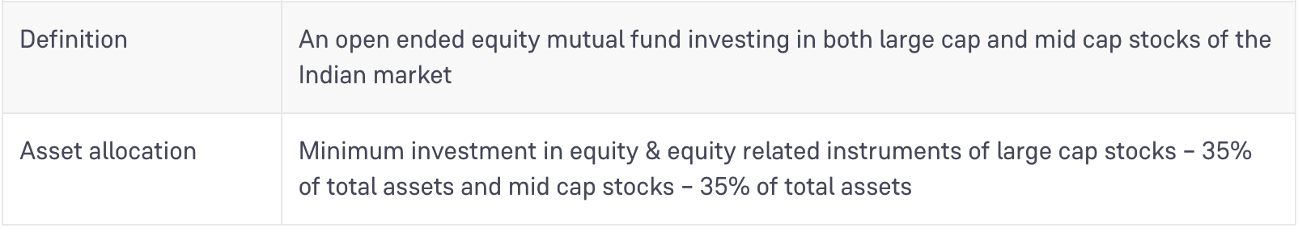
Source: Groww
Dono funds ka benchmark same hai:
NIFTY LargeMidcap 250 TRI (Total Return Index).
Invesco India Large & Mid Cap Fund January 01, 2013 ko launch hua tha, whereas Motilal Oswal Large and Midcap Fund October 17, 2019 ko launch hua.
Ab baat karte hai AUM ki. Invesco India Large & Mid Cap Fund ka AUM hai ₹11,164 Crore, whereas Motilal Oswal Large and Midcap Fund ka AUM hai ₹18,413 Crore, as of July 2026.
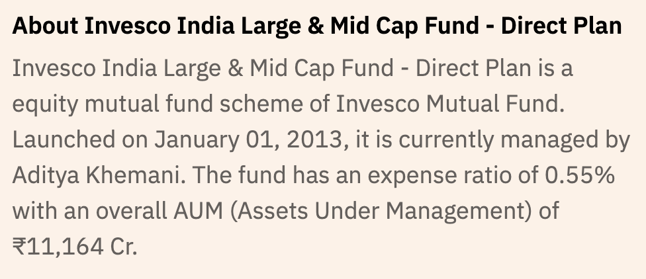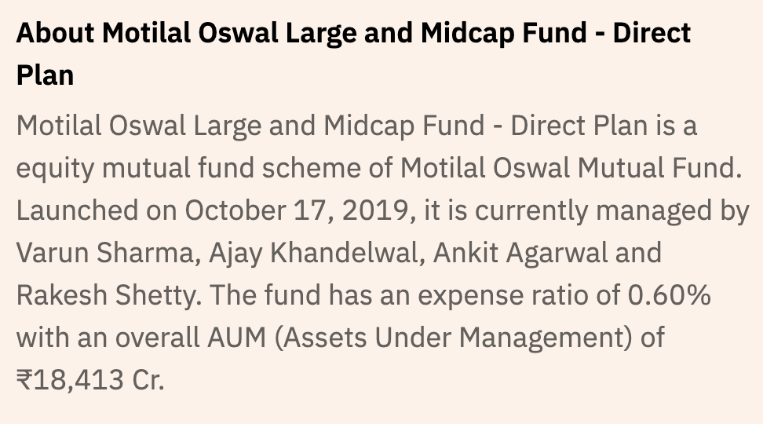
Source: Value Research
Toh, kaun hai in dono funds ke fund managers?
Invesco India Large & Mid Cap Fund ke Fund Manager Mr. Aditya Khemani hain, jo B.Com (Hons) aur PGDBM qualified investment professional hain. Unhe equity market mein 20+ saal ka experience hai aur ye Invesco AMC ke saath November 2013 se judey hai.
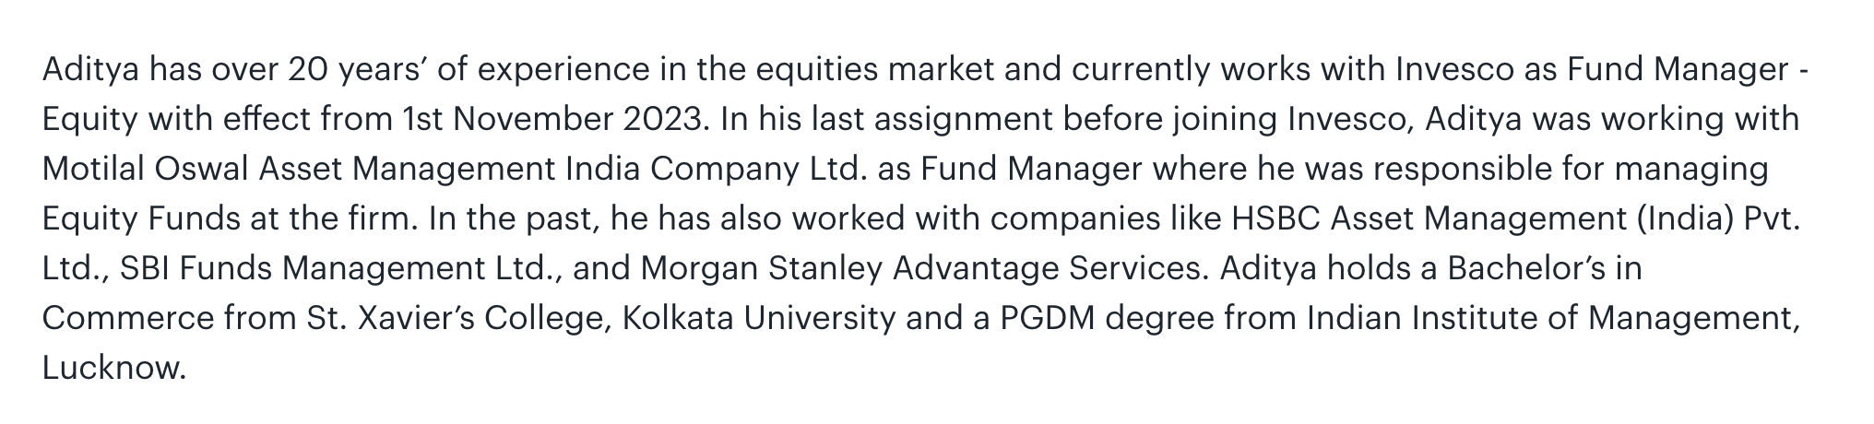
Source: Invesco India
AND
Motilal Oswal Large and Midcap Fund ek team-managed fund hai, jise Mr. Atul Mehra, Mr. Ajay Khandelwal, Mr. Ankit Agarwal, Mr. Rakesh Shetty, aur Mr. Swapnil P Mayekar saath mein manage karte hai.
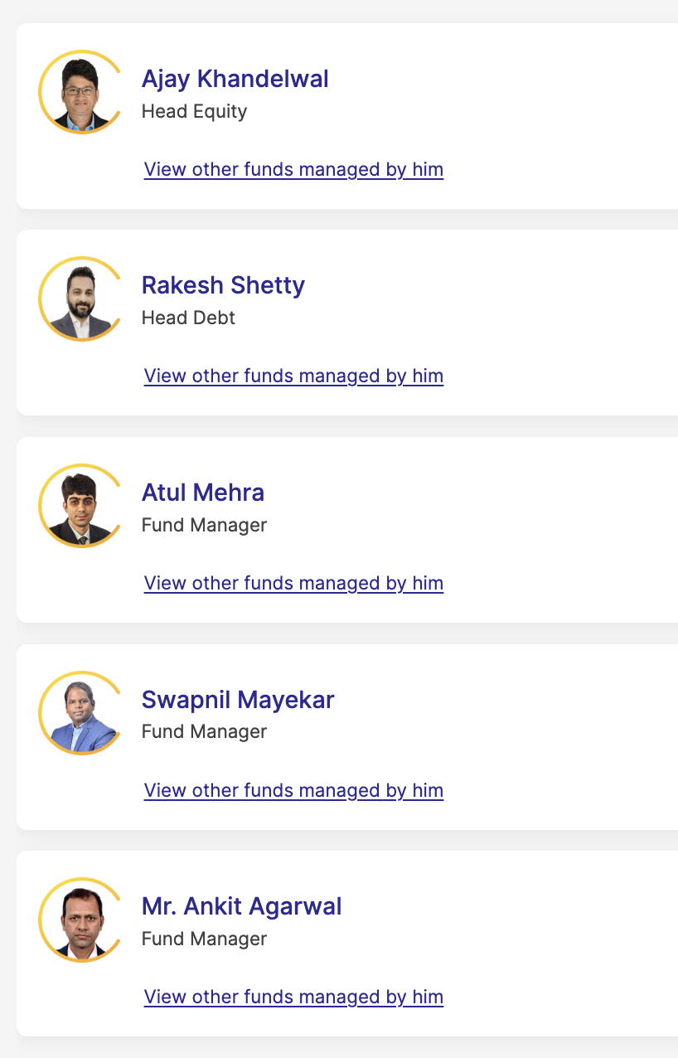
Source: Motilal Oswal Mutual Fund
Ab dekhte hai, inn funds ke investment philosophy ke baare mein.
Invesco India Large & Mid Cap Fund ka portfolio 4 key themes ke around banaya gaya hai. Sabse bada allocation hai Financials mein, 29.2%, lekin yeh apne benchmark ke muqable 1.0% underweight hai.
Healthcare mein fund ka allocation hai 19.1%, jo benchmark se 11.9% overweight hai. Fund manager ka view hai ki yeh sector India ke consumption growth ka ek proxy play hai, relatively better valuation par.
Consumer Discretionary mein 17.3% allocation hai long-term demand potential capture karne ke liye, 3.2% overweight compared to benchmark.
Aur Real Estate mein 7.7% allocation hai, 6.1% overweight compared to benchmark.
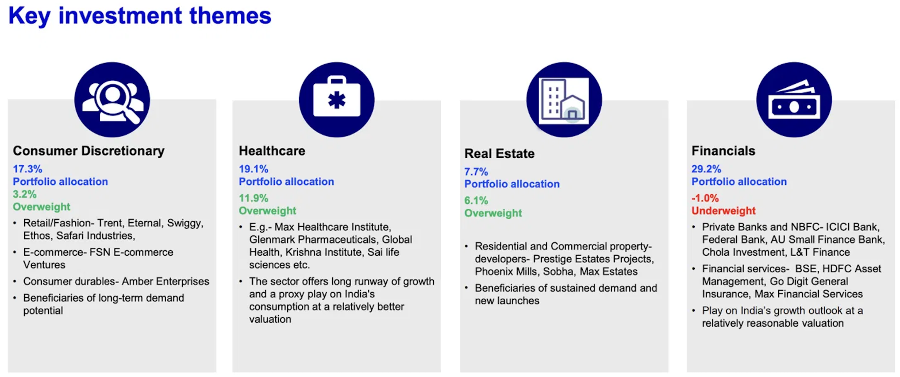
Source: Invesco India (data as of April 30, 2026)
Motilal Oswal Large and Midcap Fund ek alag philosophy follow karta hai - QGLP framework, yaani Quality, Growth, Longevity, aur Price.
Q ka matlab hai Quality. Companies ko select karne ke liye minimum ROCE ya ROE threshold set kiya jaata hai.
G aur L ka matlab hai Growth aur Longevity. Investment team collectively aise sustainable themes identify karti hai jinme growth lambe samay tak chal sake.
P ka matlab hai Price - PE aur PEG framework use hota hai, jise DCF (Discounted Cash Flow), implied returns, aur implied growth ke through expand kiya jaata hai.
Portfolio construction mein, fund ka 65% house theme representation aur stock picking par based hai, 25% flexibility hai house themes ke bahar invest karne ki, aur 10% risk mitigation ke liye reserved hai.
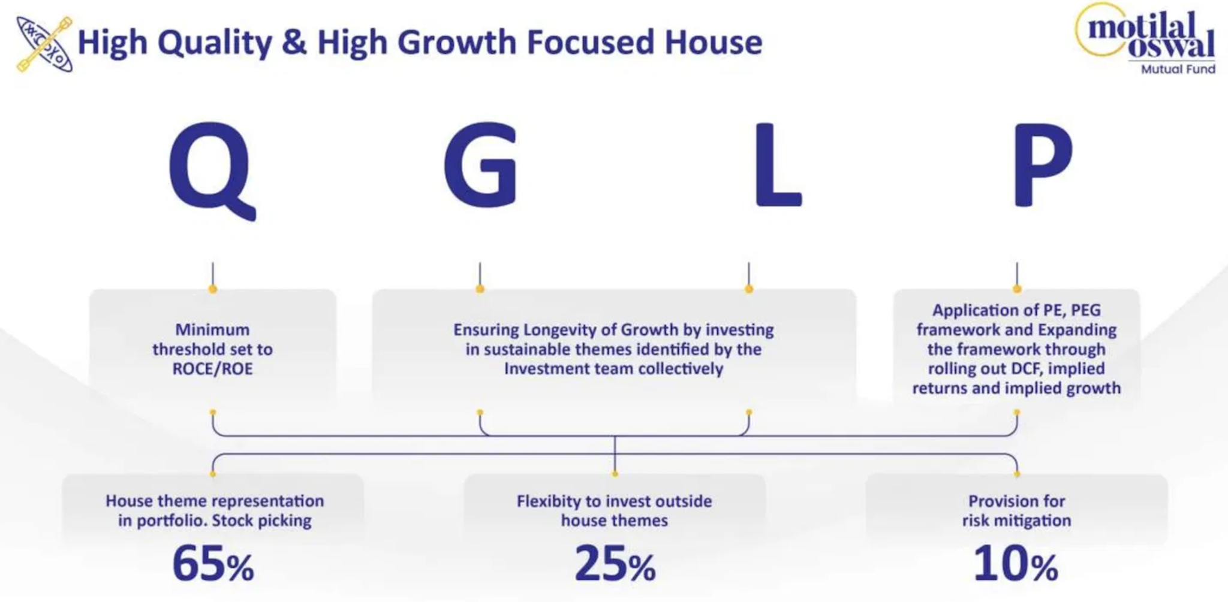
Fund ke growth-oriented themes mein China+1, Make in India, Financialisation, Tech & Tech Services, Urbanisation, Healthcare Ecosystem, aur Telecom shamil hai.
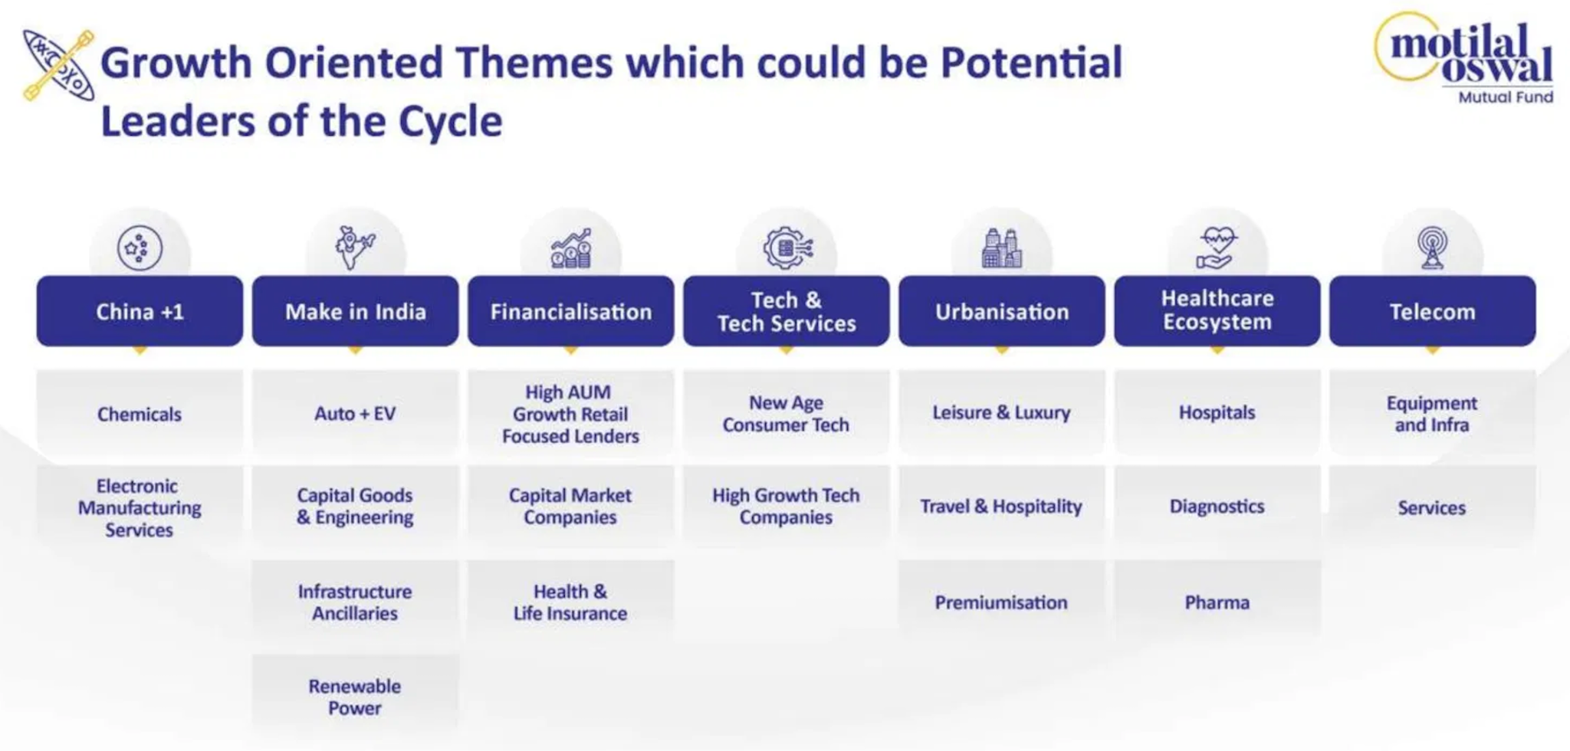
Ab hum in donom funds ke portfolio ke baare mein jaante hain.
Invesco India Large & Mid Cap Fund ka portfolio mein 40 stocks hai. Top 5 stocks portfolio ka 33.55% hold karte hai, aur top 10 stocks 53.42% hold karte hai.
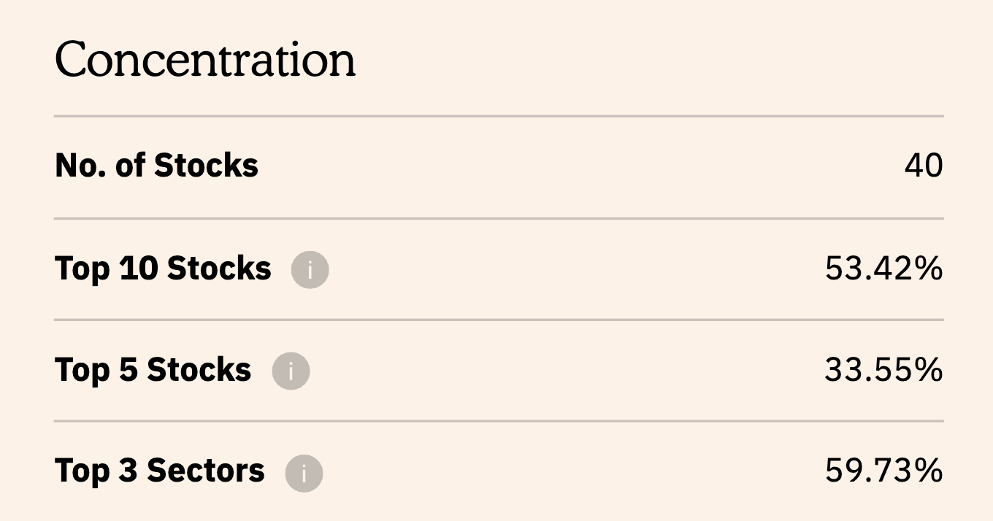Source: Value Research
Motilal Oswal Large and Midcap Fund ka portfolio zyada concentrated hai, jisme sirf 29 stocks hai. Top 5 stocks portfolio ka 23.36% hold karte hai, aur top 10 stocks 43.76% hold karte hai.
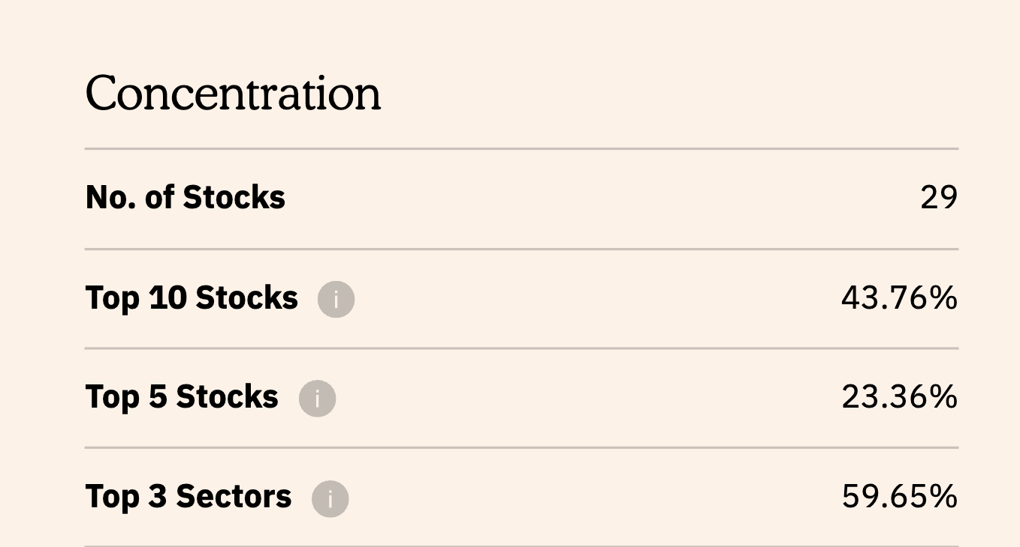Source: Value Research
Dono funds ke top 3 sectors combined portfolio ka lagbhag same hissa hold karte hai. Invesco India Large & Mid Cap Fund mein top 3 sectors 59.73% hai, jabki Motilal Oswal Large and Midcap Fund mein top 3 sectors 59.65% hai.
Invesco India Large & Mid Cap Fund Direct Growth

Motilal Oswal Large and Midcap Fund Direct Growth
Source: Value Research
Ab baat karte hai market cap allocation ki. Invesco India Large & Mid Cap Fund ka allocation hai: Large-cap 37.43%, Mid-cap 38.33%, aur Small-cap 24.24%. Category average large-cap allocation 52.75% hai, toh Invesco apne category ke muqable large-cap mein kam aur small-cap mein zyada exposure rakhta hai.
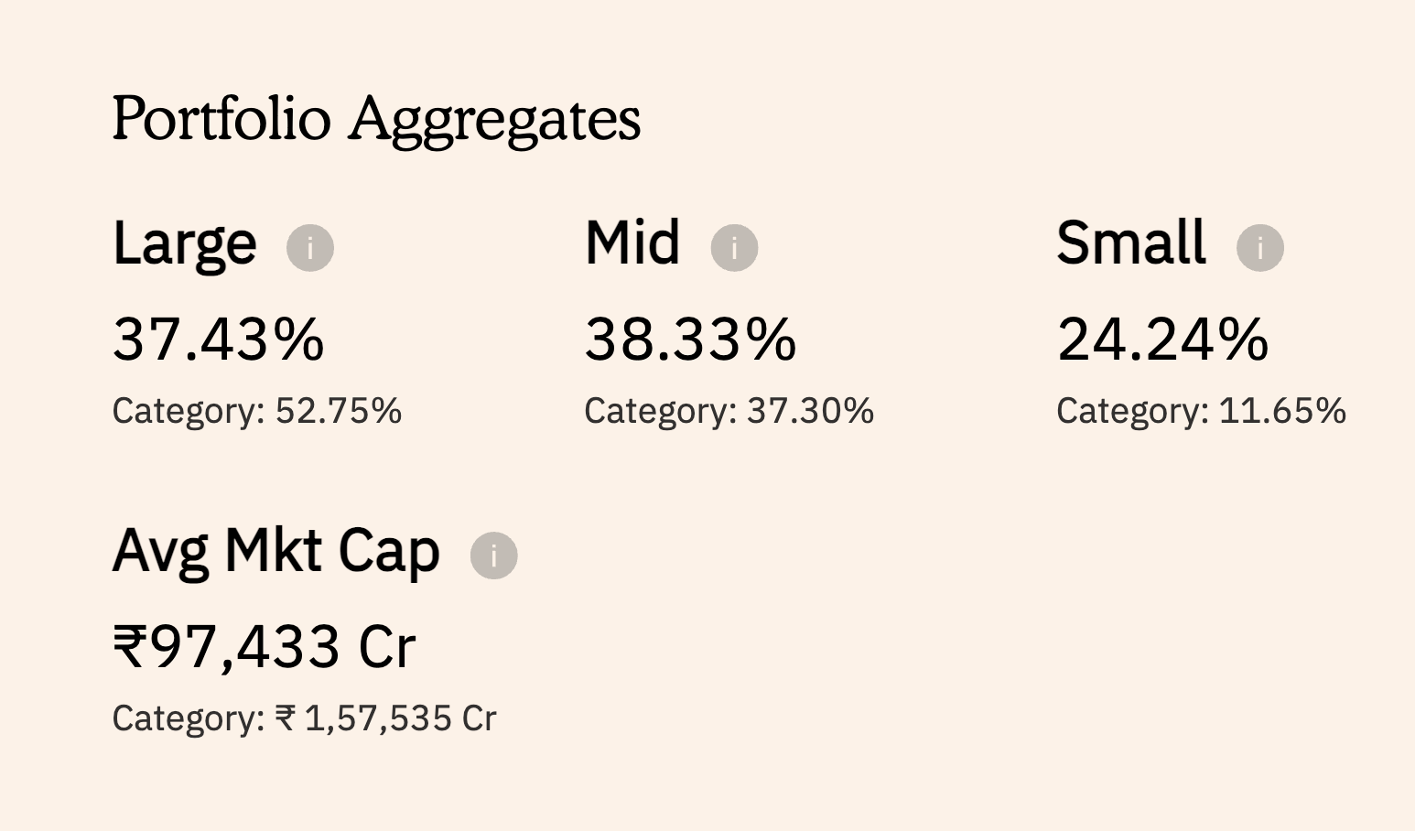Source: Value Research
Motilal Oswal Large and Midcap Fund ka allocation hai: Large-cap 39.57%, Mid-cap 31.79%, aur Small-cap 28.64%. Yeh fund bhi apne category average se large-cap mein kam exposure rakhta hai, aur dono funds mein Motilal Oswal ka small-cap tilt zyada hai.
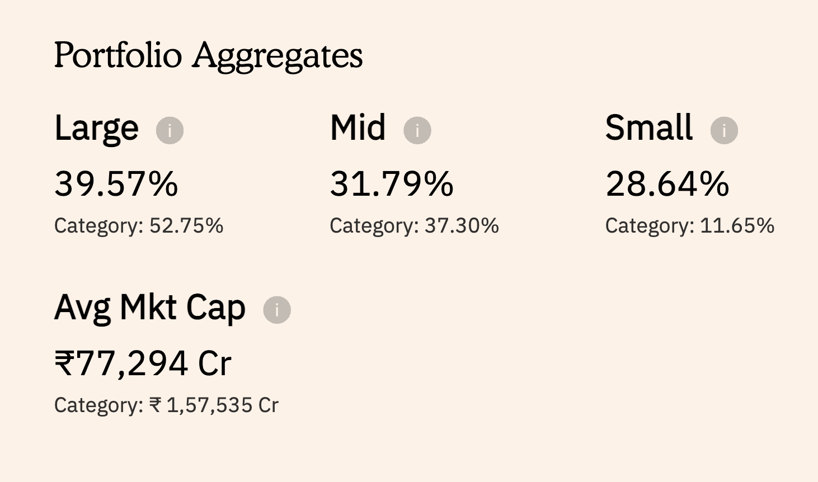Source: Value Research
Average market cap ki baat karein toh, Invesco India Large & Mid Cap Fund ka average market cap hai ₹97,433 Crore, jabki Motilal Oswal Large and Midcap Fund ka average market cap hai ₹77,294 Crore. Category average ₹1,57,535 Crore hai, yaani dono hi funds apne category ke muqable chhoti companies mein zyada invest karte hai.
Invesco India Large & Mid Cap Fund Direct Growth
Motilal Oswal Large and Midcap Fund Direct GrowthSource: Value Research
Valuation ki baat karein toh, Invesco ka Portfolio P/E Ratio Motilal Oswal ka Portfolio P/E Ratio se zyada hai aur Portfolio P/B ratio comparitively kam hai. Yeh dikhata hai ki dono funds ki valuation aur portfolio composition ek doosre se alag hai.
Benchmark ke comparison mein, dono funds ka Portfolio P/E aur P/B ratio zyada hai, jo batata hai ki dono funds benchmark ke muqable relatively higher-valued companies mein invest karte hain. Yeh difference sector allocation aur stock selection ki wajah se bhi ho sakta hai.

Valuation Metric | Invesco India Large & Mid Cap Fund | Motilal Oswal Large & Midcap Fund | NIFTY LargeMidcap 250 (Benchmark)
Portfolio P/E Ratio | 48.34 | 46.23 | 24.60
Portfolio P/B Ratio | 5.26 | 7.06 | 3.71
*Direct Growth
Source: Value Research & Screener
Portfolio turnover ki baat karein toh, Invesco India Large & Mid Cap Fund ka reported turnover hai 61.82%, jabki Motilal Oswal Large and Midcap Fund ka reported turnover hai 42.35%, dono hi March 31, 2025 tak ke data ke hisaab se. Yaani Invesco apne portfolio mein relatively zyada frequently changes karta hai.

Fund  (* Direct Growth) | Portfolio Turnover Ratio (as of March 31, 2025)
Invesco India Large & Mid Cap Fund | 61.82%
Motilal Oswal Large and Midcap Fund | 42.35%
Source: Morningstar
Ab,
Sirf portfolio composition dekhkar equity funds ko judge karna kaafi nahi hota. Chaliye ab risk aur risk-adjusted returns ki baat karte hai.
Pehla metric hai Standard Deviation, jo yeh batata hai ki fund ke returns kitna fluctuate karte hai apne average return ke comparison mein.
Invesco India Large & Mid Cap Fund ka Standard Deviation hai 18.36, jabki iski category ka average 16.24 hai. Motilal Oswal Large and Midcap Fund ka Standard Deviation hai 21.33. Yaani dono hi funds apni category se zyada volatile hai.

Metric | Invesco India Large & Mid Cap Fund | Motilal Oswal Large and Midcap Fund | Category Average
Standard Deviation | 18.36 | 21.33 | 16.24
* Direct Growth
Source: Morningstar
Ab baat karte hai Beta ki. Beta measure karta hai ki fund benchmark ke comparison mein kitna volatile hai. Beta 1 se zyada matlab fund benchmark se zyada volatile hai.
Invesco India Large & Mid Cap Fund ka Beta hai 1.08, jabki Motilal Oswal Large and Midcap Fund ka Beta hai 1.17. Category average hai 0.97. Yaani dono hi funds apne benchmark se zyada volatile hai.
Metric | Invesco India Large & Mid Cap Fund | Motilal Oswal Large and Midcap Fund | Category Average
Beta | 1.08 | 1.17 | 0.97
* Direct Growth
Source: Morningstar
Alpha ki baat karein toh, Invesco India Large & Mid Cap Fund ka Alpha hai 8.11, jabki iski category ka average sirf 0.62 hai. Motilal Oswal Large and Midcap Fund ka Alpha hai 6.36. Yaani dono hi funds apne benchmark se kaafi zyada excess return generate kar rahe hai.

Metric | Invesco India Large & Mid Cap Fund | Motilal Oswal Large and Midcap Fund | Category Average
Alpha | 8.11 | 6.36 | 0.62
* Direct Growth
Source: Morningstar
Ab baat karte hai Sharpe Ratio ki, jo har extra unit of risk ke liye fund ne kitna extra return diya, yeh batata hai.
Invesco India Large & Mid Cap Fund ka Sharpe Ratio hai 0.94, jabki Motilal Oswal Large and Midcap Fund ka Sharpe Ratio hai 0.77. Category average 0.59 hai. Toh dono hi funds apni category se behtar risk-adjusted returns de rahe hai.

Metric | Invesco India Large & Mid Cap Fund | Motilal Oswal Large and Midcap Fund | Category Average
Sharpe Ratio | 0.94 | 0.77 | 0.59
* Direct Growth
Source: Morningstar
Ab chaliye dekhte hai Upside aur Downside Capture Ratio ko.
Upside Capture Ratio batata hai ki jab market upar jaata hai, fund apne benchmark ke comparison mein kaisa perform karta hai. 100 se zyada matlab fund ne benchmark se behtar perform kiya.
Invesco India Large & Mid Cap Fund ka Upside Capture Ratio hai 132, jabki Motilal Oswal Large and Midcap Fund ka hai 133. Category average 101 hai. Yaani dono hi funds rising market mein apni category se kaafi aage nikal jaate hai.

Metric | Invesco India Large & Mid Cap Fund | Motilal Oswal Large and Midcap Fund | Category Average
Upside Capture Ratio | 132 | 133 | 101
* Direct Growth
Source: Morningstar
Downside Capture Ratio batata hai ki jab market girta hai, fund us fall mein kitna neeche jaata hai. 100 se kam matlab fund benchmark se kam gira, jo achhi baat hai.
Invesco India Large & Mid Cap Fund ka Downside Capture Ratio hai 104, jabki Motilal Oswal Large and Midcap Fund ka hai 116. Category average 99 hai. Yaani falling market mein donom funds category se zyada girta hai.

Metric | Invesco India Large & Mid Cap Fund | Motilal Oswal Large and Midcap Fund | Category Average
Downside Capture Ratio | 104 | 116 | 99
* Direct Growth
Source: Morningstar
Ab baat karte hai Maximum Drawdown ki, jo yeh dikhata hai ki fund apne peak se kitna neeche gira sabse bura phase mein.
Invesco India Large & Mid Cap Fund ka Maximum Drawdown hai -17.08%, jo October 2024 se February 2025 tak, yaani 5 months tak chala.
Motilal Oswal Large and Midcap Fund ka Maximum Drawdown hai -24.12%, jo January 2025 se February 2025 tak, yaani 2 months tak chala. Benchmark Index ka average maximum drawdown -18.15% hai.
Yaani Motilal Oswal Large and Midcap Fund ka drawdown apni category se kaafi zyada gehra raha hai, jabki Invesco apni category ke kaafi kareeb raha.

Metric | Invesco India Large & Mid Cap Fund | Motilal Oswal Large and Midcap Fund | Benchmark Index Average
Maximum Drawdown | -17.08% | -24.12% | -18.15%
Drawdown Period | Oct 2024 – Feb 2025 (5 months) | Jan 2025 – Feb 2025 (2 months) | -
* Direct Growth
Source: Morningstar
Ab baat karte hai returns ki, yaani fund ki actual performance ki.
Invesco India Large & Mid Cap Fund ne pichhle 1 saal mein 13.45% return diya hai, jabki iska benchmark sirf 4.56% aur category average 8.27% raha. Isi wajah se yeh apni category mein 3rd rank par hai.
Wahin Motilal Oswal Large and Midcap Fund ne 8.43% return diya, jo benchmark se toh behtar hai aur category average 8.17% se bhi thoda upar hai. Lekin category mein iska 18th rank hai. Yaani pichhle 1 saal mein Invesco ne clear outperformance dikhayi hai.
Ab 3-year performance dekhte hain.
Invesco ne 25.73% CAGR return generate kiya, jabki benchmark 12.30% aur category average 16.76% raha. Isi wajah se yeh category mein 1st rank par hai.
Dusri taraf, Motilal Oswal ne 23.17% CAGR diya, jo benchmark aur category dono se kaafi behtar hai. Iska category rank 2nd hai. Yaani 3-year horizon par dono funds ne outstanding performance di hai.
Ab 5-year returns ki baat karein.
Invesco India Large & Mid Cap Fund ne 18.71% CAGR return diya, jabki benchmark 11.76% aur category average 14.68% raha. Iska category rank 2nd hai.
Wahin Motilal Oswal Large and Midcap Fund ne 18.88% CAGR return diya, jo Invesco se marginally zyada hai. Benchmark aur category average se yeh bhi kaafi aage raha, aur isi wajah se yeh category mein 1st rank par hai.
Overall dekha jaaye toh, dono funds ne har time period mein benchmark aur category average ko comfortably outperform kiya hai.

Metric | Invesco India Large & Mid Cap Fund | Motilal Oswal Large and Midcap Fund
1-Year Return | 13.45% | 8.43%
1-Year Benchmark Return | 4.56% | 4.56%
1-Year Category Return | 8.27% | 8.17%
1-Year Rank (Category) | 3 | 18
3-Year Return | 25.73% | 23.17%
3-Year Benchmark Return | 12.30% | 12.30%
3-Year Category Return | 16.76% | 16.78%
3-Year Rank (Category) | 1 | 2
5-Year Return | 18.71% | 18.88%
5-Year Benchmark Return | 11.76% | 11.76%
5-Year Category Return | 14.68% | 14.70%
5-Year Rank (Category) | 2 | 1
* Direct Growth
Source: Value Research
Ab return consistency check karne ke liye in funds ke discrete returns par nazar daalte hain. 2020 se lekar aaj tak, Invesco India Large & Mid Cap Fund ne 6 mein se 2 saalon mein category aur benchmark ko outperform kiya hai, jabki Motilal Oswal Large & Mid Cap Fund ne isi period mein 6 mein se 3 saalon mein category aur benchmark ko outperform kiya hai.
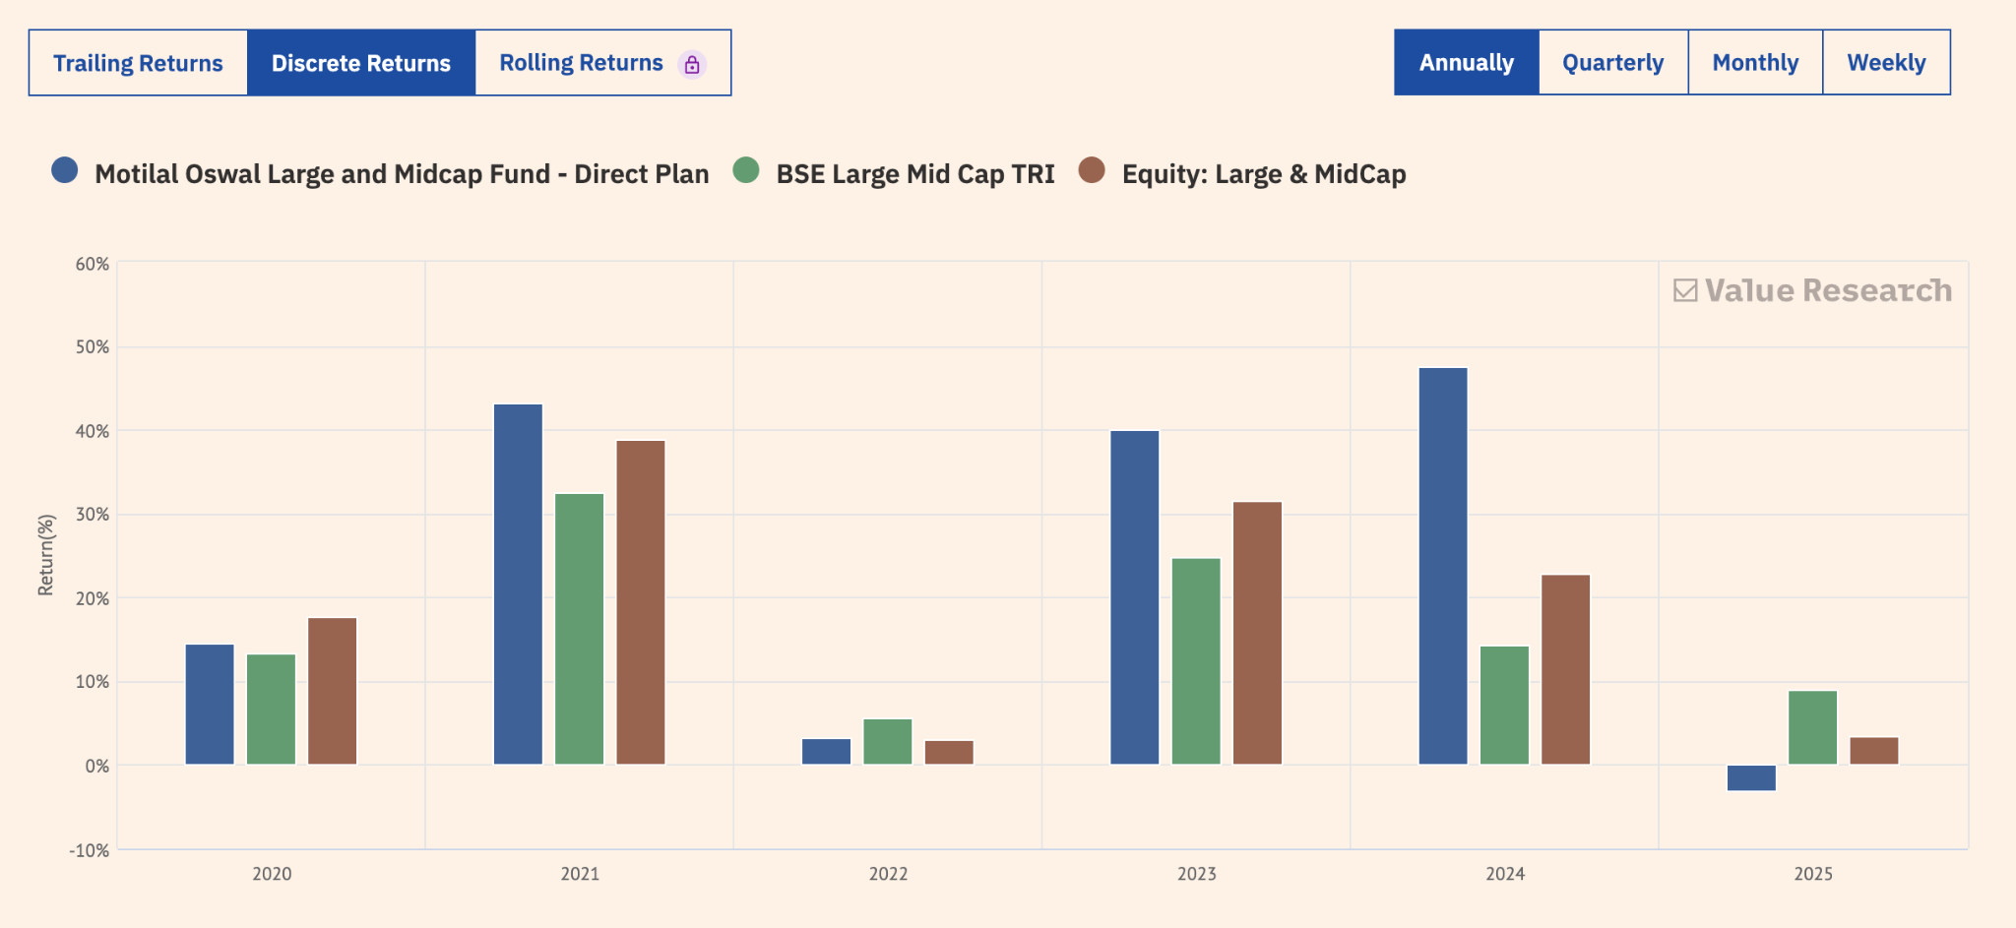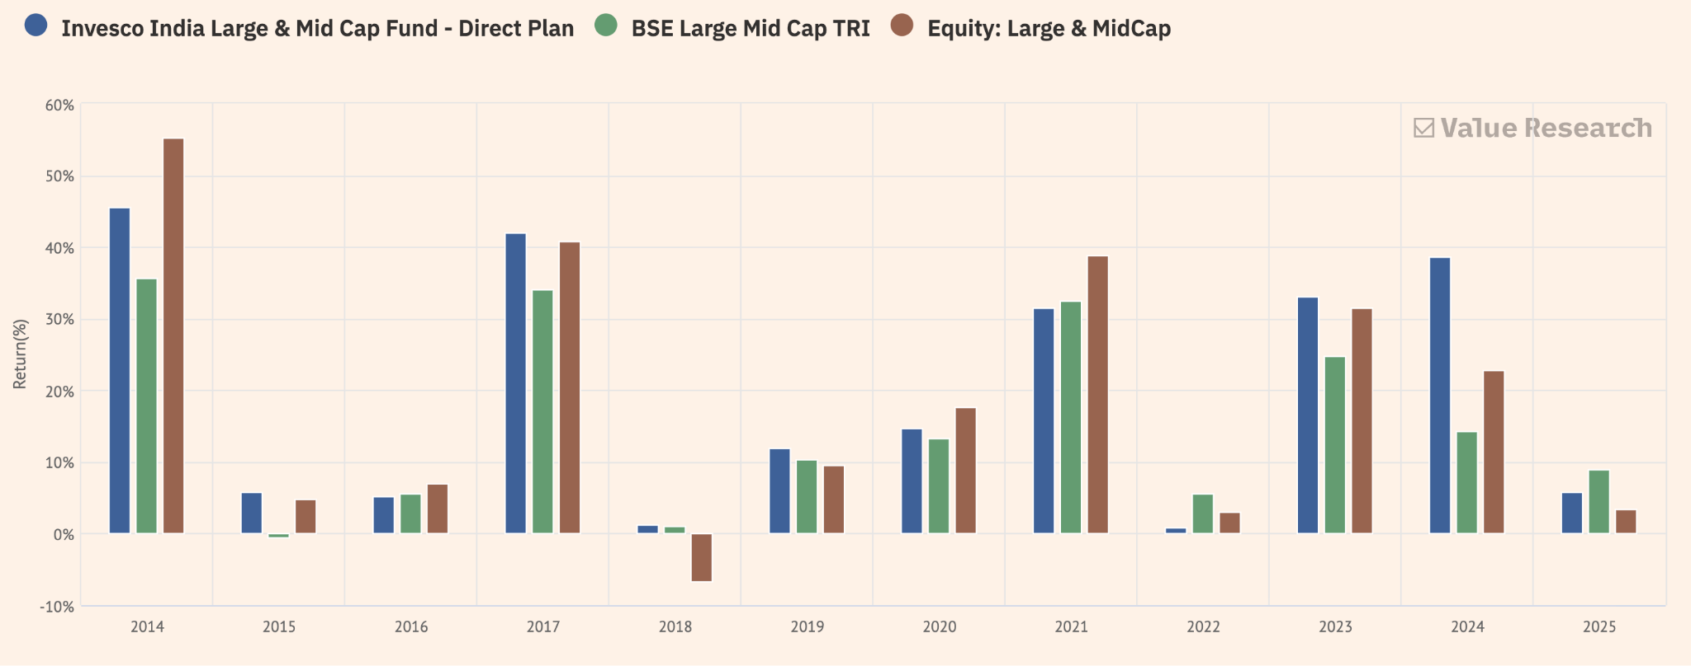
Ab baat karte hai expense ratio ki, yaani fund ko manage karne ke liye har saal li jaane wali fee.
Invesco India Large & Mid Cap Fund ka expense ratio 0.56% hai, jabki Motilal Oswal Large and Midcap Fund ka expense ratio 0.90% hai.
Expense ratio jitna kam hota hai, utna hi kam aapke returns se har saal charges ke roop mein deduct hote hain. Isliye, agar do funds ki performance lagbhag similar ho, toh lower expense ratio wale fund ko ek natural advantage milta hai, especially long-term investing mein jahan compounding ki wajah se yeh difference aur bada ho sakta hai.
Metric | Invesco India Large & Mid Cap Fund | Motilal Oswal Large and Midcap Fund
Expense Ratio | 0.56% | 0.90%
* Direct Growth
Source: Morningstar

Conclusion
Toh yeh raha in dono funds ka comparison. Dono hi funds ka investment approach kaafi alag hai. Ek taraf portfolio construction, sector positioning aur portfolio turnover mein difference dekhne ko milta hai, toh doosri taraf volatility, drawdown aur risk-adjusted return metrics mein bhi dono ki apni alag characteristics hain.
Performance ke perspective se dekhein, toh dono funds ne alag-alag time periods mein benchmark aur category average se behtar returns deliver kiye hain. Saath hi, risk metrics bhi yeh dikhate hain ki higher return ke saath risk profile ko bhi samajhna utna hi zaroori hai. Isliye kisi bhi equity fund ko evaluate karte waqt sirf past returns ya category ranking par focus karne ke bajay, uski investment philosophy, portfolio strategy, risk characteristics aur yeh sab aapki apni risk appetite aur financial goals se kitna match karte hain, is par bhi dhyan dena chahiye.
Yaad rahe, yeh video sirf educational purpose ke liye banayi gayi hai. Isme diye gaye securities ya investments recommendatory nahi hain.
Agar yeh video helpful laga ho, toh like karein, share karein, aur channel ko subscribe karna na bhoolein. Milte hain next video mein. Until then, bye!

Disclaimer: This is solely for educational purposes. The securities/investments quoted here are not recommendatory.
To read the RA disclaimer, please click here.
RA Sign :

Research Analyst : Shreesha Ramesh Desai
RA Date : 07-08-2026

